Once you are logged in to the BrickFTP site, navigate to “All Files” tab on the left side. The folder is called “mmi_automation.”

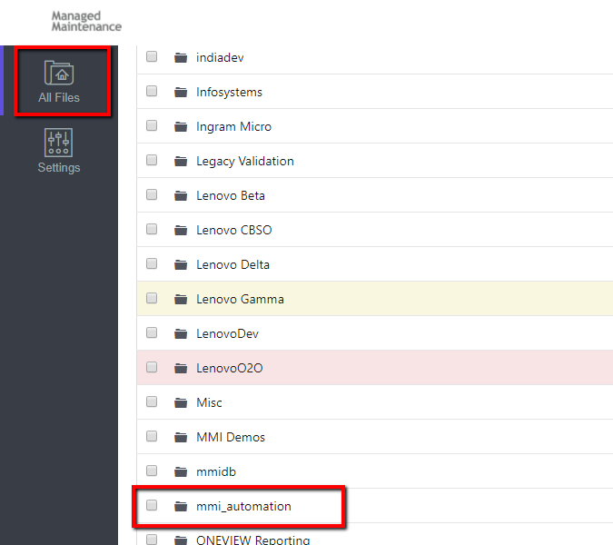

When you find this file, you will see a hover icon to “download.” Download the whole file mmi_automation and place it on your “C:” drive.

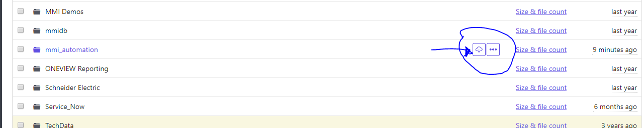

The sub folder with all the correct executable files in “mmi_auto_testing_AdvancedSearch.”

Disregard the rest as they are previous versions.

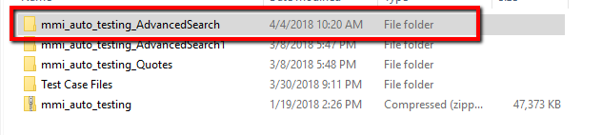

All the executable files are in the “Bin” folder. The file with the test cases and scenarios are in the “data” folder.

Once you have placed the “mmi_automation” folder on your C: drive, all you have to do is navigate to the mmi_auto_testing_AdvancedSearch sub folder and then bin folder. Double click any executable and it should run without any problems.

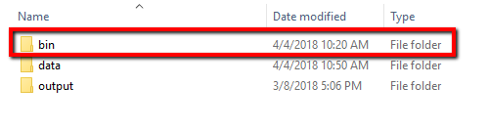

You can modify the input data on the first/second row of the file like Agreement ID #, Agreement Type, CF Program level, Dates, ect.

